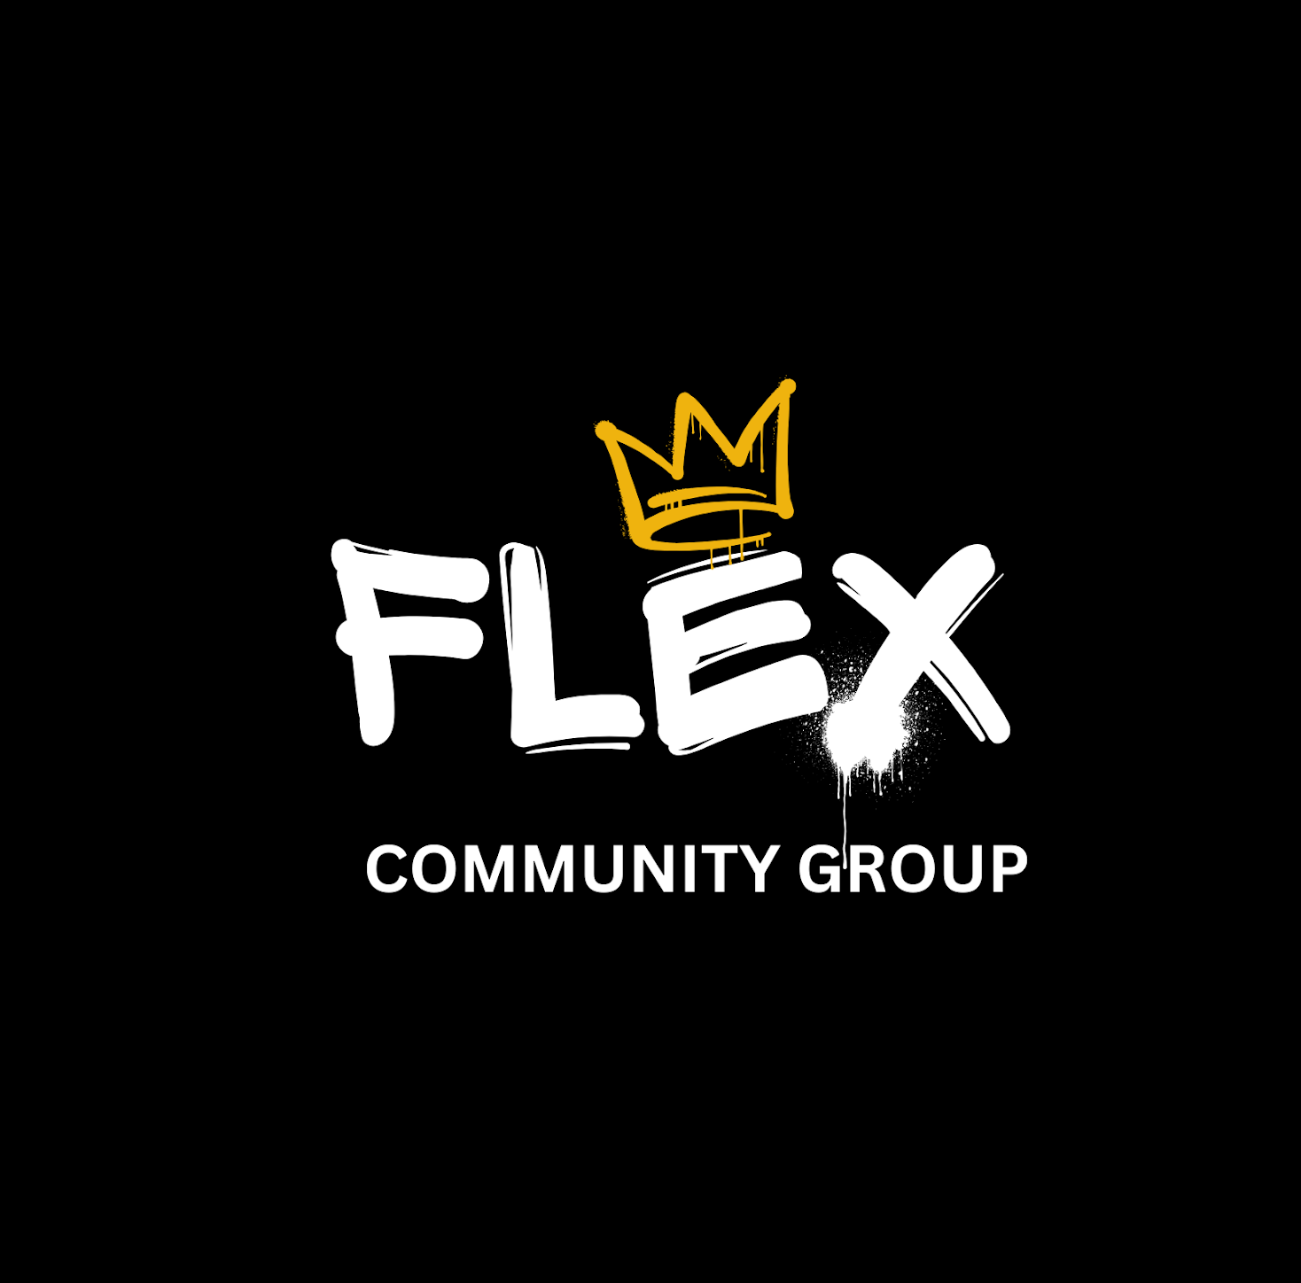
FLEX YOUTH & COMMUNITY GROUP
YOUNG PERSON REFERRAL FORM
Please complete as much information as possible.Once completed, email to either flexyouthclub@gmail.com or jordan.flexyouth@gmail.com A member of the Flex team will review the referral and contact you regarding next steps.
1. YOUNG PERSON'S DETAILS

Full name *  __________________________________ | Date of birth *  __________________________________
School / college  __________________________________ | Year group  __________________________________
Home area / postcode  __________________________________ | Preferred pronouns (optional)  __________________________________
Parent / carer name  __________________________________ | Parent / carer telephone  __________________________________
Parent / carer email ____________________________________________________________
2. REFERRER DETAILS

Your name *  __________________________________ | Organisation / school  __________________________________
Your role  __________________________________ | Relationship to young person  __________________________________
Email address *  __________________________________ | Telephone number *  __________________________________
3. REASON FOR REFERRAL

Please tick any areas where support may be helpful:
☐ Confidence / self-esteem ☐ Emotional wellbeing ☐ Behaviour / emotional regulation
☐ Social skills / friendships ☐ School engagement ☐ Mentoring / support
☐ Positive activities ☐ Sport / physical activity ☐ Social isolation
☐ Other: _______________________________________________________________
Please tell us a little more about the referral. *
What support would you like the young person to receive from Flex?
________________________________________________________________________________
________________________________________________________________________________
________________________________________________________________________________
4. INTERESTS & STRENGTHS

What does the young person enjoy, show an interest in, or respond well to?
For example: football, gaming, music, dance, art, cooking, group activities or 1-to-1 support.
________________________________________________________________________________
________________________________________________________________________________
________________________________________________________________________________
5. ADDITIONAL SUPPORT

Does the young person have any additional needs we should be aware of? ☐ Yes ☐ No ☐ Unsure
If yes, or if there is anything else that would help us support them effectively, please provide relevant information:
________________________________________________________________________________
________________________________________________________________________________
________________________________________________________________________________
6. SAFEGUARDING & RISK

Are there any current safeguarding concerns or known risks that Flex needs to be aware of? ☐ Yes ☐ No
If yes, please provide relevant details:
________________________________________________________________________________
________________________________________________________________________________
________________________________________________________________________________
Important: This form should not be used to report an immediate safeguarding emergency. Please follow your organisation's safeguarding procedures and contact the appropriate emergency or statutory service where required.
7. AWARENESS & CONSENT

Is the young person aware that this referral is being made? ☐ Yes ☐ No
Has the parent / carer been informed of the referral? ☐ Yes ☐ No ☐ Not applicable
Does the parent / carer consent to Flex contacting them? ☐ Yes ☐ No ☐ Not yet obtained
☐ I confirm that the information provided is accurate to the best of my knowledge and that I am authorised to share this information with Flex Youth & Community Group.
Referrer's signature  __________________________________ | Date  __________________________________
THANK YOU FOR YOUR REFERRAL
Once received, a member of the Flex team will review the referral and contact you regarding next steps.

