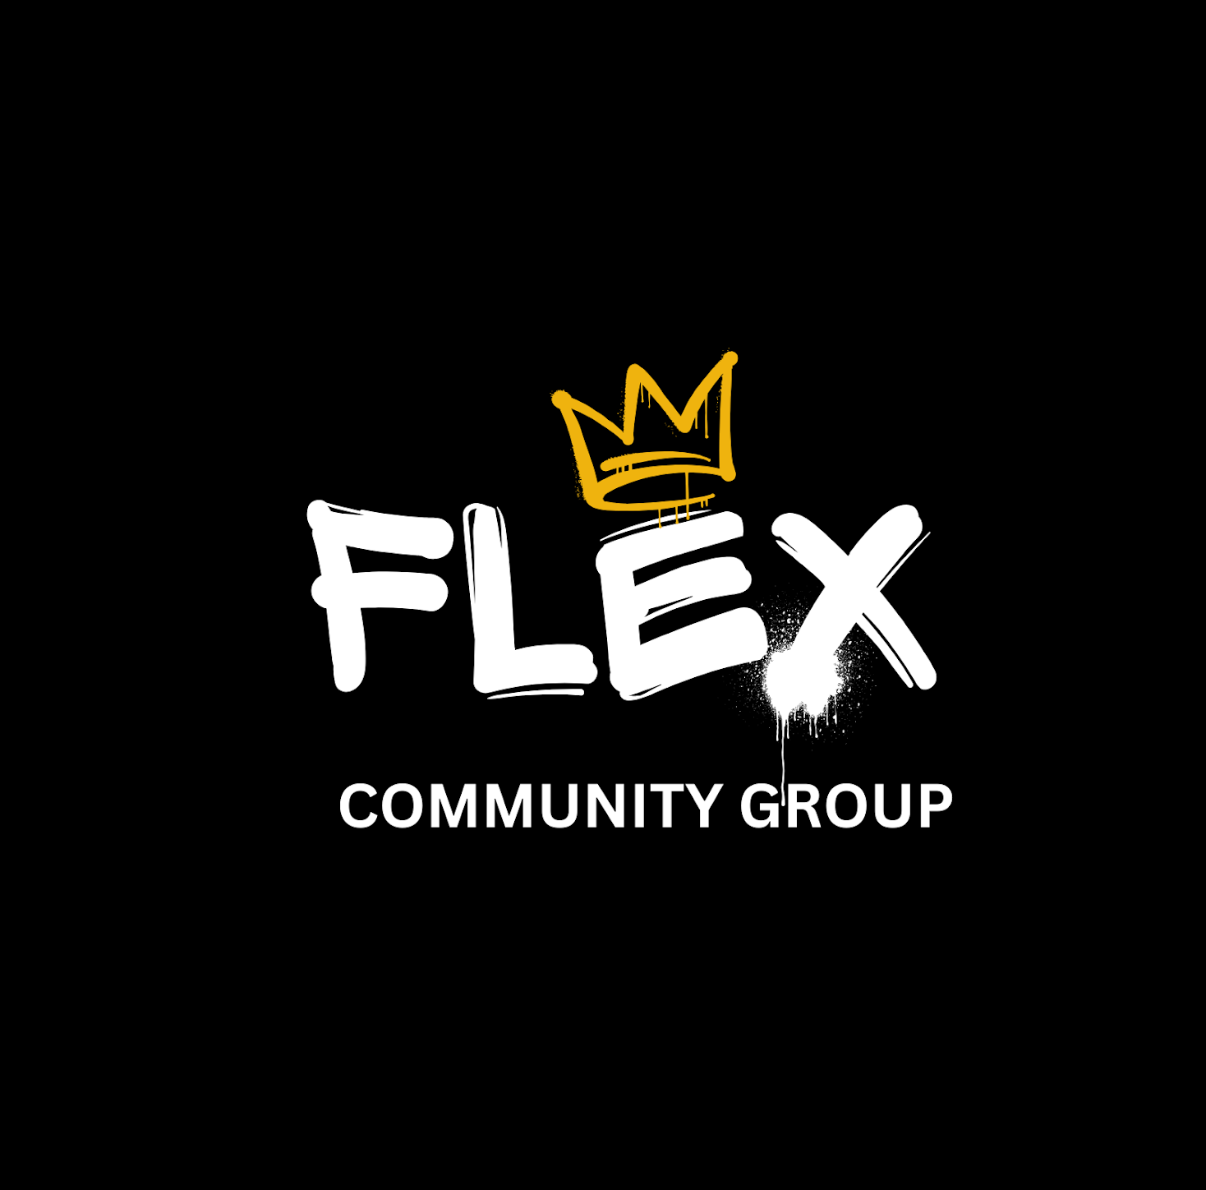
FLEX YOUTH & COMMUNITY GROUP
VOLUNTEER APPLICATION FORM
Event & Activity Support | Applicants must be aged 18+
Thank you for your interest in volunteering with Flex. Our volunteers help create welcoming, positive spaces for young people by supporting activities, events and our wider team. Please complete this form so we can get to know you and understand where you may fit best. Once completed email to either flexyouth@gmail.com or jordan.flexyouth@gmail.com
1. YOUR DETAILS

Full name *  __________________________________ | Date of birth *  __________________________________
Telephone number *  __________________________________ | Email address *  __________________________________
Home area / postcode ____________________________________________________________
Are you aged 18 or over? ☐ Yes ☐ No
2. ABOUT YOU

Why would you like to volunteer with Flex? *
________________________________________________________________________________
________________________________________________________________________________
________________________________________________________________________________
Tell us briefly about any experience, skills or interests you could bring.
This could include work, volunteering, sport, youth work, events, cooking, creative activities or lived experience.
________________________________________________________________________________
________________________________________________________________________________
________________________________________________________________________________
What do you hope to gain from volunteering with Flex?
________________________________________________________________________________
________________________________________________________________________________
3. VOLUNTEER INTERESTS

Which areas would you be interested in supporting? (Tick all that apply)
☐ Youth sessions / activities ☐ Sports activities ☐ Community events
☐ Trips / outings ☐ Kitchen / refreshments ☐ Setting up / packing down
☐ Welcoming / registration ☐ General event support ☐ Other: __________________________
4. AVAILABILITY

When are you generally available? (Tick all that apply)
☐ Weekday daytime ☐ Weekday evenings ☐ Saturdays ☐ Sundays
☐ School holidays ☐ One-off events ☐ Regular weekly volunteering
Please add any details about your availability or preferred commitment:
________________________________________________________________________________
________________________________________________________________________________
5. WORKING WITH YOUNG PEOPLE

Do you have any previous experience working or volunteering with children or young people?
If yes, briefly tell us where, what your role involved and the age groups you worked with.
________________________________________________________________________________
________________________________________________________________________________
________________________________________________________________________________
What do you think makes a good volunteer when working with young people?
________________________________________________________________________________
________________________________________________________________________________
6. SAFER RECRUITMENT

Do you currently hold an Enhanced DBS certificate? ☐ Yes ☐ No ☐ Unsure
Is your DBS registered with the Update Service? ☐ Yes ☐ No ☐ Not applicable
Flex can support successful applicants to obtain the appropriate DBS check where required.
Are there any relevant circumstances that may affect your suitability to volunteer with children or young people that you need to discuss with us? ☐ Yes ☐ No
If yes, please provide brief details or state if you would prefer to discuss this confidentially:
________________________________________________________________________________
________________________________________________________________________________
7. EMERGENCY CONTACT

Emergency contact name  __________________________________ | Relationship to you  __________________________________
Emergency contact telephone number ____________________________________________________________
8. REFERENCE

Please provide one person we may contact for a reference. This should not be a family member.
Reference name  __________________________________ | Relationship / capacity  __________________________________
Email address  __________________________________ | Telephone number  __________________________________
9. DECLARATION

☐ I confirm that the information provided in this application is accurate to the best of my knowledge. I understand that volunteering with Flex is subject to appropriate safer recruitment checks, which may include references, identity checks and a DBS check where required.
☐ I understand that information provided will be handled in accordance with Flex Youth & Community Group's privacy and data protection procedures.
Applicant signature  __________________________________ | Date  __________________________________
THANK YOU FOR WANTING TO JOIN THE FLEX TEAM
We will review your application and contact you regarding the next stage.

